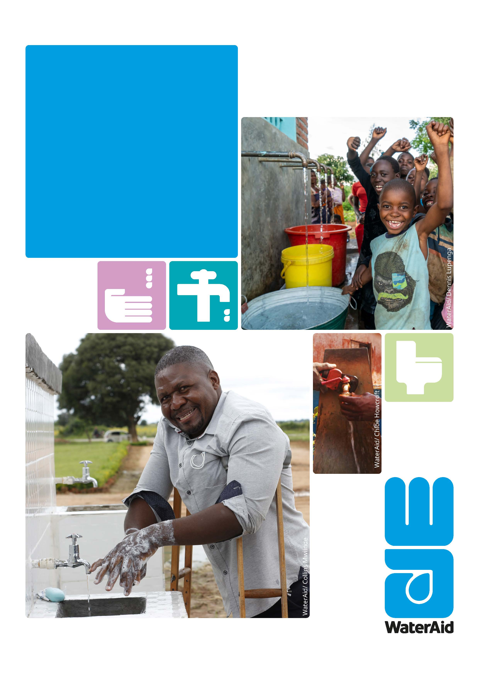
Job Description
Regional Advocacy Manager
Southern Africa

Permanent/Full time
WaterAid is an international not-for-profit, determined to make clean water, decent toilets and good hygiene normal for everyone, everywhere within a generation.
Since we started in 1981, we’ve remained resolutely focused on tackling these three essentials that transform people’s lives
Without all three, people can’t live dignified, healthy lives. With all three, they can unlock their potential, break free from poverty, and change their lives for good. Children grow up healthy and strong, women and men get to earn a living, whole communities start to thrive. It sounds normal and it should be.

We’re committed to changing normal forever—are you?

WaterAid is fully committed to protecting those with whom it comes into contact. WaterAid is committed to ensuring that wherever we work in the world there is no tolerance for the abuse of power, privilege or trust. WaterAid reinforces a culture of zero tolerance towards any form of inappropriate behaviour, abuse, harassment, or exploitation of any kind. The safeguarding of our beneficiaries, staff, volunteers and anyone working on our behalf, is our top priority, and we take our responsibilities extremely seriously. All staff and volunteers are required to share in this commitment through our Global Code of Conduct. We will conduct the most appropriate pre-employment references and checks to ensure high standards are maintained.

For more information about safeguarding at WaterAid, please visit our safeguarding webpage at: https://www.wateraid.org/uk/safeguarding-at-wateraid

Job Title | Regional Advocacy Manager, Southern Africa
Place of work: | Regional Office, South Africa or in any of the WaterAid Southern Africa Country Programmes
Pay band: | Grade H (Blended)
Salary: | tbc
Contract type: | Permanent / Full Time
Reports to: | Regional Director, Southern Africa
Manages: | Policy Specialist
Budget responsibility:
Travel: | Predominantly in Southern Africa region with occasional travel to London

Job purpose
The Regional Advocacy Manager (RAM) is a senior role and member of the regional team in the International Programmes Department (IPD) of WaterAid. The RAM will lead and manage regional initiatives around advocacy, policy analysis and research. S/he will support the Regional Director in this influencing role, and Country Programmes to strengthen their advocacy and policy influencing work.

S/he will also be the nodal person at the regional level for global advocacy initiatives and work with the Pan Africa Programme Manager (PAPM), RAMs of other Regions towards the achievement of WA’s ambitious global strategic aims
The role will be expected to lead our advocacy and influencing, by exploring regional collaborative opportunities, building strong influencing alliances, and advocating for change in how WASH is delivered in the region to bring about equitable and permanent change to poor and marginalized people. This will entail also drawing on our well-established programmes to make significant contribution to further improve impactful programme design and delivery.

S/he will report to the Regional Director and will maintain a strong professional and functional relationship with the Global Heads of Policy and Campaigns and Communication Teams in Country Programmes and across the WaterAid Federation . S/he will also maintain professional relationship with other senior regional team members and Country Directors.

Responsibilities

Strategic Planning, Leadership and Management
- Lead and manage the development and implementation of the regional influencing strategy as reflected in the Regional Strategy (RS) in order to support the delivery of WaterAid’s Global Strategy, ensuring that the RS is aligned with both the Global and Country Strategies.

- Plan and develop proposals for regional advocacy, influencing, campaigning and research to contribute to the delivery of the Regional Strategy and proactively engage with raising resources for the same.

- Critically assess strategic opportunities in the countries in the region and support WA to develop its influencing plans and strengthen relationships with governments, donors and other key stakeholders in the sector.

- Support Country Programmes in the development and implementation of high level advocacy strategies and objectives as well as strengthen their advocacy and influencing work, and coordinate capacity building for CPs and partners.

- Contribute to regional team responsibilities such as regional reporting, compilation and dissemination of the regional operational plans and be an effective member of the Regional Leadership Team (RLT) and Regional Management Team (RMT).

Advocacy and Campaigning
- Scan the external policy, economic and political environment, critically assess opportunities in the region and identify strategic opportunities and agencies for influencing the regional water, sanitation and hygiene promotion agenda to address the factors that deny poor people’s rights to access improved WASH services.

- Lead regional as well as global advocacy and influencing programmes and campaigns and facilitate support to CPs within the region.

- Support and contribute to the development of WA sub-continental influencing initiatives (e.g. Pan Africa, SADC, Regional Media Network, etc) and actively contribute to the agenda setting process for delivering support for WASH at higher level meetings.

- Contribute to global campaigns and support CPs and partners in planning, budgeting and rolling out of campaigns including participation in WA’s Global Advocacy working groups.

Learning, Research and Knowledge Management
- Lead and manage regional learning initiatives around advocacy, policy analysis and research.

- Critically analyse outcomes and impact of WA’s advocacy and policy influencing work in the region in order to document and share key learning and good practice using the organisational PMER systems and other tools.

- Initiate and lead thematic and policy research to inform advocacy and influencing in the region and contribute to the thematic work of other champions as appropriate.

Collaborative Work
- Identify and support the development and/or strengthening of regional WASH sector programmes, partnerships and civil society networks.

- Lead and support the development of linkages with media, research and academic institutions in countries and the region, and facilitate collaboration in policy development and influencing within the region.

- Closely work with the Regional team, lead and coordinate the Regional Advocacy, Policy, Campaign and Communications working closely with the Regional Communications Manager and all key internal and external stakeholders

- Maximise WA’s impact by using all appropriate opportunities to advocate and promote WASH externally across the development sector and beyond it.

Representation
- Coordinate cross-regional and organisation-wide advocacy and influencing initiatives relevant to the region, and represent the Regional Director, Southern Africa Region in regional and global events.

- Be the voice of the region on advocacy and influencing issues, and act as the key spokesperson for the region supported by the RCM.

- Perform any other tasks as delegated by the Regional Director.

Person specification

Essential
Education
- Post-graduate / Masters’ degree in public policy / public administration, political science, development studies, law or equivalent.
Knowledge
  - A demonstrable commitment to poverty reduction and social justice issues.
  - An understanding of technical, social and institutional issues relating to water, sanitation and hygiene promotion in developing countries (both rural and urban).
  - Knowledge of development policies, especially the WASH sector and its challenges and blockages, and how they can be addressed
  - Knowledge of research methodologies and ethical issues in northern-southern research co-operation.
  - Understanding the role of policy analysis, research and advocacy work in development
  - Knowledge of the complexities of working with wide and diverse Civil Society coalitions, in particular NGO policy and advocacy networks and social movements in the region.
  - Knowledge of how regional agencies and key stakeholders operate in the region.
  - A good understanding of the social, political, policy and institutional environments of countries and the region.
Experience
  - Extensive senior level experience of action research and policy analysis, preferably in an international agency, based in the region.
  - Proven experience of advocacy and policy work and activity planning
  - A successful track record of influencing key-decision makers including governments and the official donor community
  - Experience of lobbying and / or campaigning work in the region
  - Experience of developing and facilitating training programmes for development organisations and networks.
  - A successful track record in the design and delivery of highly successful advocacy and policy strategies
  - Experience of rights-based programming in advocacy and campaigning.
  - Experience in gender transformative programming, management and implementation
  - Leading and engaging teams and individuals.
Skills
  - Excellent oral and written communication skills in English.
  - A team player, able to work in a collaborative manner with staff at a distance.
  - Ability to communicate clearly and persuasively to high level target audiences - both professional/specialist and lay audiences.
  - Ability to coach and mentor country staff and partners.
  - Highly developed political acumen.
  - Ability to write fundable proposals for raising resources, managing donor relations.
  - Self-starter and ability to work with minimum supervision.

Others
  - Ability to travel.
  - Ability to work in a multi-cultural, multi-lingual and multi-country team.
  - Commitment to WaterAid’s values and a working style that reflects these.

Desirable
- Post Graduate qualification in a WASH related Subject.
  - A successful track record of negotiating around political structures, and within the constraints of policy making processes and environments in the region.
  - Knowledge of bilateral and multilateral donors, and funding mechanisms in the region
  - Experience of working with regional and/or sub-continental organisations, institutions and networks in the WASH sector.
  - Experience of managing research projects and commissioning research in an international or regional context.
  - Experience of active participation and lobbying in the context of international conferences.
  - Experience of successful work with international agencies and official policy-making processes.
  - Oral and written communication skills in a relevant regional language and in French or Portuguese.
  - Public relations skills.
  - Ability to manage personal workload and wellbeing when faced with multiple deliverables

